Abolaji Shiwoku

10/4/2020

Guided Capstone Report

This report summarizes the findings to the problem statement whether Big Mountain Resort is charging fair market value for weekend passes for their resort. The resort is unsure of how their prices compare with their competitors, and desire a quantitative model that they can help justify ticket price changes. We were supplied a dataset that consisted of several resorts and their features, such as skiable area, highest vertical drop, snow making capability, total number of chairs, and other numerical features.

We constructed a supervised machine learning model called a Random Forest. The desired response of the model is the adult ticket price which is a byproduct of the derived value of the resorts’ attractions. The price data that we used to inform the model had this distribution:

We then run the model and have the model predict the price of the resort based on the attraction they offer, and the results are: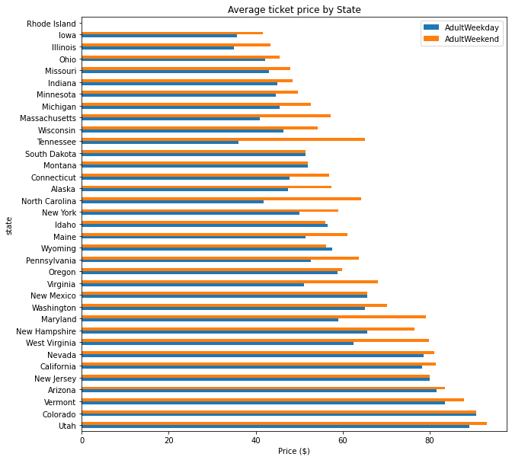

**Big Mountain Resort modelled price is $104.03, actual price is $81.00.**

The model predicts that the current price is underpricing what the resort should be charging its customers. These results must be taken into context: we had no information regarding the origin nor the general financial scope of their customers, so we can make no predictions on how their customers would react to a price increase. We had no information regarding operating costs, which may be a significant factor about the current ticket pricing.

The team was also instructed to predict the ticket price effect if the resort made additions or decided to shut down less profitable attractions in their resort. The scenario that would result in the decrease in the ticket price support, assuming that the model is using all the important data to predict, would be to close up to 10 of the least profitable runs. A visual representation of the results are shown:

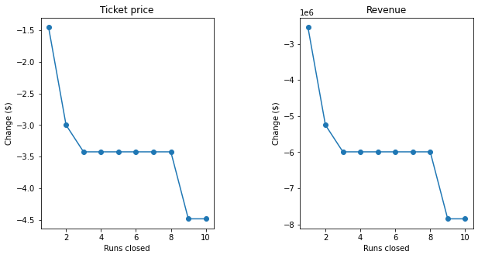

We can see the ticket price support changes drastically from 1 to 2 runs closed and 8 to 9 runs closed. Those seem like the logical levels to determine the number of runs to close. The other promising scenario to increase ticket price was to build additional facilities for the resort customers, such as building an additional lift, adding arun, and increasing the vertical drop of the highest run by 150 ft. When supplied to the model, the model predicted an estimated increase in the ticket price support of $1.36, as well as an increase of $2,386,364 in revenue.

Based on the results, scenario 2 provides the most upside, due to its increased capacity to serve more customers. The additional lift and run will allow the resort to service more customers, which will allow them to justify higher prices. The downfall of this scenario could be that if the resort’s customers may be inelastic to the price change, or they may be driven to cheaper alternatives than Big Mountain Resort.